**Decision tree**

**Accuracy of the model:**

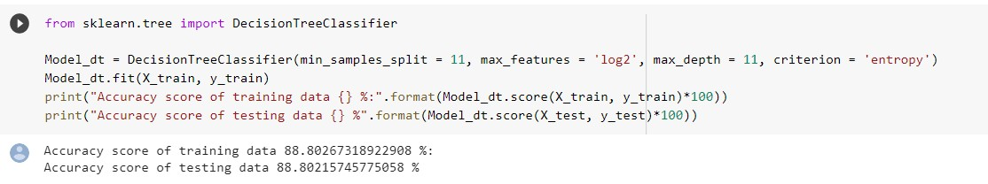

The accuracy obtained from Decision tree model is 88.802%

**NAIVE BAYES**

**Accuracy of the model:**

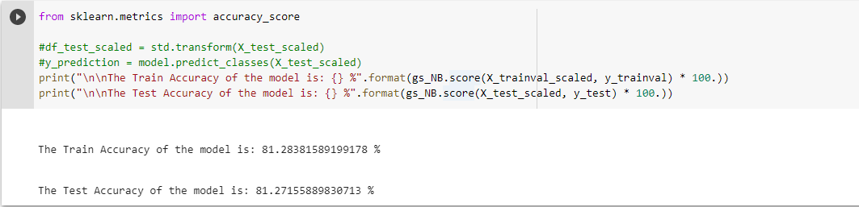

The accuracy obtained from Naïve Bayes model is 81.27%

**KNN (k-nearest neighbors)**

**Accuracy of the model:**

